**DAILY ONLINE ACTIVITIES SUMMARY**

|  |  |  |  |  |  |  |  |  |
| --- | --- | --- | --- | --- | --- | --- | --- | --- |
| Date: | 08/06/2020 | | | | | Name: | Jyothi B R | |
| Sem & Sec | IV-A | | | | | USN: | 4AL18CS030 | |
| Online Test Summary | | | | | | | | |
| Subject | | 18MAT41 | | | | | | |
| Max. Marks | | 20 | | Score | | | 30 | |
| Certification Course Summary | | | | | | | | |
| Course | Programming Essentials in Python | | | | | | | |
| Certificate Provider | | | Cisco Virtual Academy | | Duration | | | 3hrs |
| Coding Challenges | | | | | | | | |
| |  |  |  | | --- | --- | --- | | |  | | --- | | Problem Statement:  Write a Java Program | |  | | | | | | | | | |
| Status:Completed | | | | | | | | |
| Uploaded the report in Github | | | | | Yes | | | |
| If yes Repository name | | | | | https://github.com/alvas-education-foundation/jyothi_b_r | | | |
| Uploaded the report in slack | | | | | Yes | | | |

Online Test Details: (Attach the snapshot and briefly write the report for the same)

Certification Course Details: (Attach the snapshot and briefly write the report for the same)

Coding Challenges Details: (Attach the snapshot and briefly write the report for the same)

**ONLINE TEST DETAILS**: The online test was from module2. There were 30 questions which contains mcq questions and the duration were 30 minutes. The questions were optimal and easy. The score that I received was 20/30.

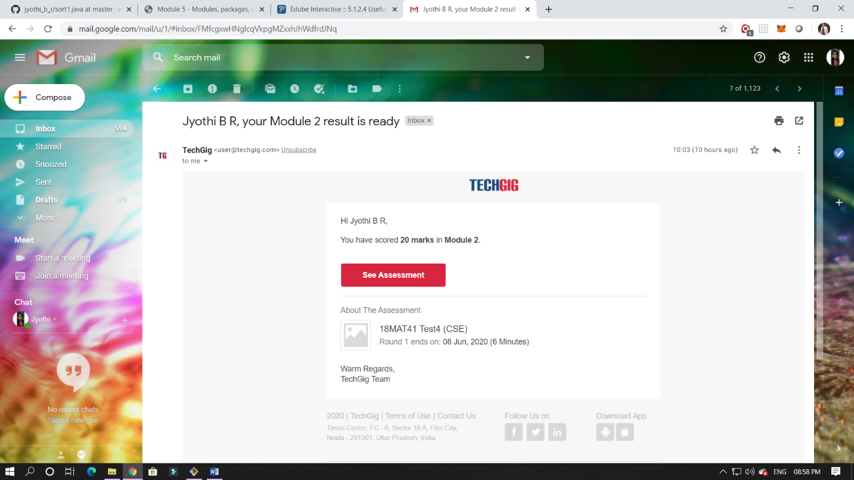

CERTIFICATION COURSE DETAILS:

Programming Essentials in Python :

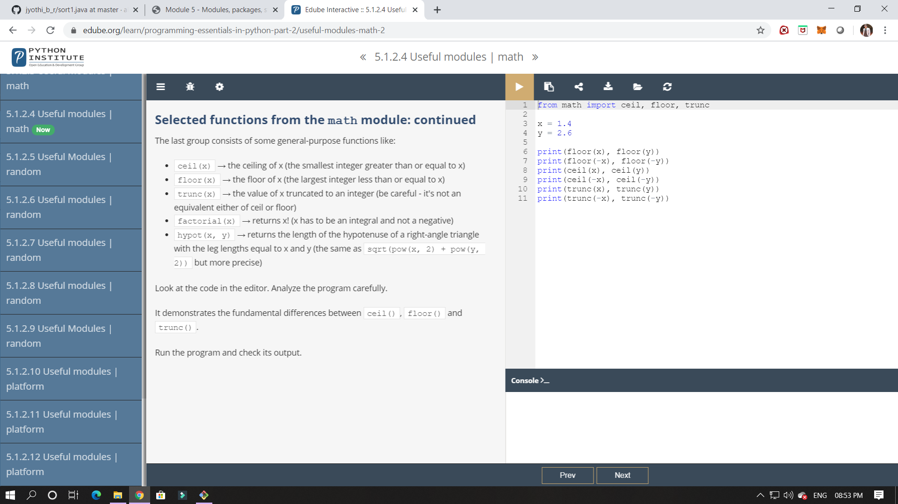

In this module its shows about modules, packages, string and its methods,and exceptions.

In this module I have studied about modules and how it can be implemented and importing the functions in it.

ONLINE CODING:

 Given an array A of size N containing 0s, 1s, and 2s; you need to sort the array in ascending order.  
Input:  
The first line contains an integer 'T' denoting the total number of test cases. Then T testcases follow. Each testcases contains two lines of input. The first line denotes the size of the array N. The second lines contains the elements of the array A separated by spaces.

Output:  
For each testcase, print the sorted array.

Constraints:  
1 <= T <= 500  
1 <= N <= 106  
0 <= Ai <= 2

